Lab 8
Binary Divider
library ieee;
use ieee.std_logic_1164.all;
use ieee.numeric_std.all;

entity binary_divider is
port
(
clk : in std_logic;
reset : in std_logic;
dividend : in std_logic_vector(3 downto 0);
divisor : in std_logic_vector(3 downto 0);
start : in std_logic;
quotient : out std_logic_vector(3 downto 0);
remi : out std_logic_vector(3 downto 0);
done : out std_logic; -- Added done signal
-- Debug outputs
debug_state : out integer range 0 to 6;
debug_counter : out integer range 0 to 4
);
end binary_divider;

architecture beh of binary_divider is
type state_type is (IDLE, LOAD, CHECK, SUBTRACT, SHIFT, DONE_STATE);
signal current_state, next_state : state_type;
signal ender : std_logic_vector(7 downto 0);
signal quotient_reg : std_logic_vector(3 downto 0); -- internal quotient
signal sor : std_logic_vector(7 downto 0);
signal counter : integer range 0 to 4; -- Shift counter
begin

-- State register process - ONLY updates state
process(clk, reset)
begin
if reset = '1' then
current_state <= IDLE;
elsif rising_edge(clk) then
current_state <= next_state;
end if;
end process;

-- Debug output for state
with current_state select debug_state <=
0 when IDLE,
1 when LOAD,
2 when CHECK,
3 when SUBTRACT,
4 when SHIFT,
5 when DONE_STATE,
6 when others;

-- Debug output for counter
debug_counter <= counter;

-- Combinational logic for next state
process(current_state, start, counter) -- Added counter to sensitivity list
begin
-- Default assignment
next_state <= current_state;

case current_state is
when IDLE =>
if start = '1' then
next_state <= LOAD;
end if;

when LOAD =>
next_state <= CHECK;

when CHECK =>
next_state <= SUBTRACT;

when SUBTRACT =>
next_state <= SHIFT;

when SHIFT =>
if counter = 3 then -- Done after 4 iterations (0,1,2,3)
next_state <= DONE_STATE;
else
next_state <= CHECK; -- Go back to CHECK for next iteration
end if;

when DONE_STATE =>
next_state <= IDLE;
end case;
end process;

-- Datapath process - ONLY place where ender, sor, quotient_reg, counter are assigned
process(clk, reset)
begin
if reset = '1' then
ender <= (others => '0');
sor <= (others => '0');
quotient_reg <= (others => '0');
counter <= 0;
quotient <= (others => '0'); -- Reset outputs
remi <= (others => '0');
done <= '0';
elsif rising_edge(clk) then
-- Default: done is low unless we're in DONE_STATE
done <= '0';

case current_state is
when IDLE =>
quotient_reg <= (others => '0');
counter <= 0;
done <= '0';

when LOAD =>
ender <= "0000" & dividend;
sor <= divisor & "0000";
counter <= 0; -- Reset counter on load

when CHECK =>
null; -- Just a pipeline stage

when SUBTRACT =>
-- Compare and conditionally subtract
if unsigned(ender) >= unsigned(sor) then
-- Remainder >= Divisor: subtract and set quotient bit to 1
ender <= std_logic_vector(unsigned(ender) - unsigned(sor));
quotient_reg <= '1' & quotient_reg(3 downto 1); -- Shift right, insert 1 on left
else
-- Remainder < Divisor: don't subtract, set quotient bit to 0
quotient_reg <= '0' & quotient_reg(3 downto 1); -- Shift right, insert 0 on left
end if;

when SHIFT =>
-- Shift divisor right by 1
sor <= '0' & sor(7 downto 1);
counter <= counter + 1;

when DONE_STATE =>
-- Reverse the quotient bits (bit 3 becomes bit 0, etc.)
remi(3) <= quotient_reg(0);
remi(2) <= quotient_reg(1);
remi(1) <= quotient_reg(2);
remi(0) <= quotient_reg(3);
quotient <= ender(3 downto 0); -- Remainder
done <= '1'; -- Signal completion
end case;
end if;
end process;

end beh;

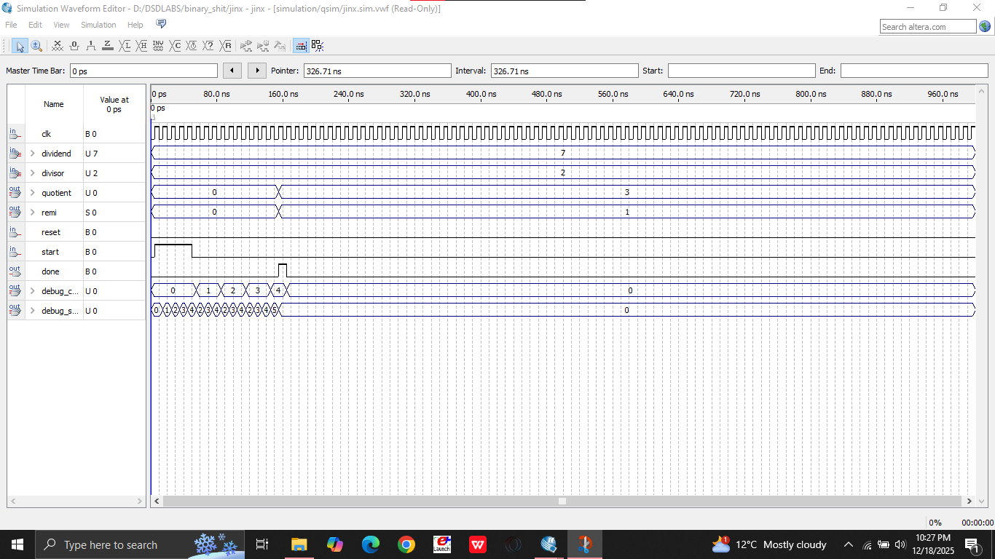
In this I am implementing a binary divider and have attempted a division of 7/2 and result is also correct. Using internal quotient and Counter signals to detect the shift in the divisor.
Lab 7
Booth’s Algo
library ieee;
use ieee.std_logic_1164.all;
use ieee.numeric_std.all;

entity booth is
generic(
N : integer := 5
);
port(
clk : in std_logic;
rst : in std_logic;
start : in std_logic;
M : in signed(N-1 downto 0); -- Multiplicand
Q_in : in signed(N-1 downto 0); -- Multiplier
P : out signed(2*N-1 downto 0); -- Final product
done : out std_logic
);
end entity;

architecture Behavioral of booth is
-- Booth's Algorithm Registers
signal A : signed(N-1 downto 0) := (others => '0'); -- Upper half
signal Q : signed(N-1 downto 0) := (others => '0'); -- Lower half
signal Qm1 : std_logic := '0'; -- Q(-1)
signal SC : integer range 0 to N := 0; -- Counter
signal M_reg : signed(N-1 downto 0) := (others => '0'); -- Stored multiplicand

-- State machine
type state_type is (IDLE, INIT, CHECK_BITS, ADD_SUB, SHIFT_REG, FINISH);
signal state : state_type := IDLE;

begin
process(clk)
begin
if rising_edge(clk) then
if rst = '1' then
A <= (others => '0');
Q <= (others => '0');
Qm1 <= '0';
SC <= 0;
M_reg <= (others => '0');
done <= '0';
state <= IDLE;

else
case state is
when IDLE =>
done <= '0';
if start = '1' then
state <= INIT;
end if;

when INIT =>
-- Initialize: A=0, Q=Multiplier, Qm1=0, SC=N
A <= (others => '0');
Q <= Q_in;
Qm1 <= '0';
M_reg <= M;
SC <= N;
state <= CHECK_BITS;

when CHECK_BITS =>
-- Just move to ADD_SUB (checking happens there)
state <= ADD_SUB;

when ADD_SUB =>
-- Check Current Bit (Q0) and Previous Bit (Qm1)
if Q(0) = '0' and Qm1 = '1' then
-- 01: Add Multiplicand to A
A <= A + M_reg;
elsif Q(0) = '1' and Qm1 = '0' then
-- 10: Subtract Multiplicand from A
A <= A - M_reg;
end if;
-- 00 or 11: No operation
state <= SHIFT_REG;

when SHIFT_REG =>
-- Arithmetic Right Shift of [A, Q, Qm1]
-- This shifts the entire Product Register as one unit
Qm1 <= Q(0); -- Q(0) moves to Qm1
Q <= A(0) & Q(N-1 downto 1); -- Q shifts, gets A(0)
A <= A(N-1) & A(N-1 downto 1); -- A shifts with sign extension

-- Decrement counter
SC <= SC - 1;

-- Check if done
if SC = 1 then
state <= FINISH;
else
state <= CHECK_BITS;
end if;

when FINISH =>
done <= '1';
state <= IDLE;

end case;
end if;
end if;
end process;

-- Final product is concatenation of A and Q
P <= A & Q;

end architecture;
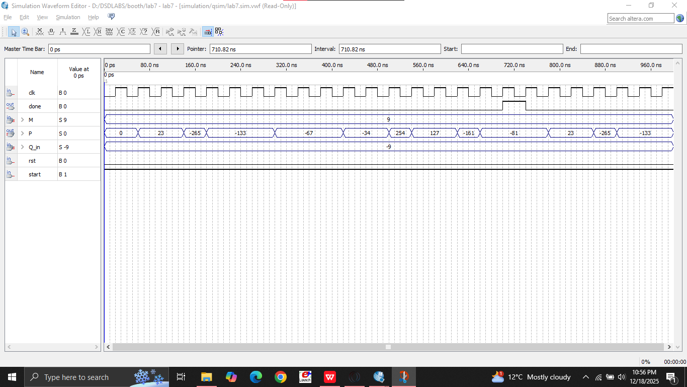

This design implements Booth’s signed multiplication using an FSM, where the accumulator and multiplier registers are conditionally added or subtracted based on adjacent multiplier bits, followed by arithmetic right shifts repeated for N cycles to produce a 2N-bit product

Lab 9

--Two way lights
library ieee;
use ieee.std_logic_1164.all;
use ieee.numeric_std.all;

entity lights is port
(
stby : in std_logic; -- Standby mode (active high)
clk : in std_logic;
light1_red : out std_logic;
light1_yellow : out std_logic;
light1_green : out std_logic;
light2_red : out std_logic;
light2_yellow : out std_logic;
light2_green : out std_logic
);
end lights;

architecture beh of lights is
-- State machine
type state_type is (YY, RG, RY, GR, YR);
signal state, next_state : state_type := YY;
signal counter : integer := 0;

-- Timing constants for 60 Hz clock
-- constant RG_TIME : integer := 1800; -- 30 seconds
-- constant RY_TIME : integer := 300; -- 5 seconds
-- constant GR_TIME : integer := 2700; -- 45 seconds
-- constant YR_TIME : integer := 300; -- 5 seconds

-- For simulation, use smaller values:
constant RG_TIME : integer := 30;
constant RY_TIME : integer := 5;
constant GR_TIME : integer := 45;
constant YR_TIME : integer := 5;

begin
---------------------------------------
-- Sequential Process
---------------------------------------
process(clk)
begin
if rising_edge(clk) then
state <= next_state;

-- Counter logic: reset on state change
if state /= next_state then
counter <= 0;
else
counter <= counter + 1;
end if;
end if;
end process;

---------------------------------------
-- Combinational Process
---------------------------------------
process(state, counter, stby)
begin
-- Default outputs (all off)
light1_red <= '0';
light1_yellow <= '0';
light1_green <= '0';
light2_red <= '0';
light2_yellow <= '0';
light2_green <= '0';

case state is
-- Standby state: Both Yellow (indefinite)
when YY =>
light1_yellow <= '1';
light2_yellow <= '1';

-- Exit standby when stby goes low
if stby = '0' then
next_state <= RG;
else
next_state <= YY;
end if;

-- RG state: Light1=Red, Light2=Green (30s)
when RG =>
light1_red <= '1';
light2_green <= '1';

-- Check for standby mode first
if stby = '1' then
next_state <= YY;
elsif counter >= RG_TIME then
next_state <= RY;
else
next_state <= RG;
end if;

-- RY state: Light1=Red, Light2=Yellow (5s)
when RY =>
light1_red <= '1';
light2_yellow <= '1';

if stby = '1' then
next_state <= YY;
elsif counter >= RY_TIME then
next_state <= GR;
else
next_state <= RY;
end if;

-- GR state: Light1=Green, Light2=Red (45s)
when GR =>
light1_green <= '1';
light2_red <= '1';

if stby = '1' then
next_state <= YY;
elsif counter >= GR_TIME then
next_state <= YR;
else
next_state <= GR;
end if;

-- YR state: Light1=Yellow, Light2=Red (5s)
when YR =>
light1_yellow <= '1';
light2_red <= '1';

if stby = '1' then
next_state <= YY;
elsif counter >= YR_TIME then
next_state <= RG; -- Loop back to start
else
next_state <= YR;
end if;

when others =>
next_state <= YY;
end case;
end process;

end beh;
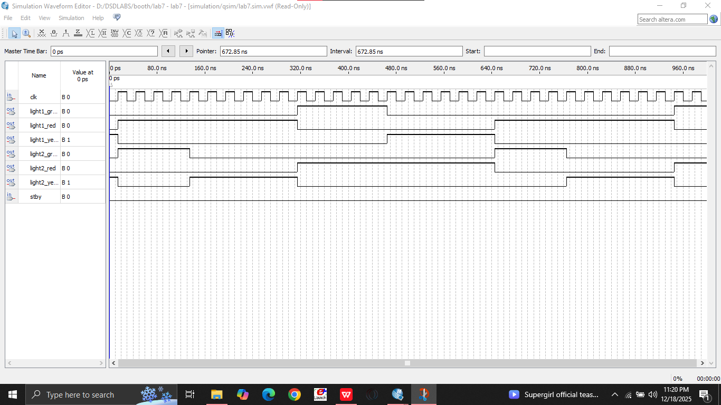
Simply just implemented the fsm and implemented the time duration using mathermatical operations.
Task 2
4-way chowk
--------------------------------------------------------------------------------
-- 4-WAY TRAFFIC LIGHT CONTROLLER - OPTION 2 (ADVANCED)
-- Each direction gets independent green light in rotation
-- Sequence: North → East → South → West → North (repeat)
--------------------------------------------------------------------------------

library ieee;
use ieee.std_logic_1164.all;

entity traffic_light_4way is port
(
clk : in std_logic; -- 60 Hz clock
reset : in std_logic; -- Active high reset
stby : in std_logic; -- Standby mode (all yellow)

-- North direction traffic light
north_red : out std_logic;
north_yellow : out std_logic;
north_green : out std_logic;

-- East direction traffic light
east_red : out std_logic;
east_yellow : out std_logic;
east_green : out std_logic;

-- South direction traffic light
south_red : out std_logic;
south_yellow : out std_logic;
south_green : out std_logic;

-- West direction traffic light
west_red : out std_logic;
west_yellow : out std_logic;
west_green : out std_logic
);
end traffic_light_4way;

architecture behavioral of traffic_light_4way is

-- Define 9 states
type state_type is (
STANDBY,
NORTH_GREENE,
NORTH_YELLOWE,
EAST_GREENE,
EAST_YELLOWE,
SOUTH_GREENE,
SOUTH_YELLOWE,
WEST_GREENE,
WEST_YELLOWE
);

signal current_state, next_state : state_type := STANDBY;
signal counter : integer := 0;

-- FOR SIMULATION: Use these small values
constant NORTH_GREEN_TIME : integer := 30;
constant EAST_GREEN_TIME : integer := 25;
constant SOUTH_GREEN_TIME : integer := 30;
constant WEST_GREEN_TIME : integer := 25;
constant YELLOW_TIME : integer := 5;

-- FOR FPGA (60 Hz clock): Uncomment these and comment above
-- constant NORTH_GREEN_TIME : integer := 1800; -- 30 seconds
-- constant EAST_GREEN_TIME : integer := 1500; -- 25 seconds
-- constant SOUTH_GREEN_TIME : integer := 1800; -- 30 seconds
-- constant WEST_GREEN_TIME : integer := 1500; -- 25 seconds
-- constant YELLOW_TIME : integer := 300; -- 5 seconds

begin

----------------------------------------------------------------------
-- SEQUENTIAL PROCESS
----------------------------------------------------------------------
process(clk, reset)
begin
if reset = '1' then
current_state <= STANDBY;
counter <= 0;

elsif rising_edge(clk) then
current_state <= next_state;

if current_state /= next_state then
counter <= 0;
else
counter <= counter + 1;
end if;
end if;
end process;

----------------------------------------------------------------------
-- COMBINATIONAL PROCESS
----------------------------------------------------------------------
process(current_state, counter, stby)
begin
-- DEFAULT: All lights RED, yellows and greens OFF
-- These execute FIRST, before the case statement
north_red <= '1';
north_yellow <= '0';
north_green <= '0';

east_red <= '1';
east_yellow <= '0';
east_green <= '0';

south_red <= '1';
south_yellow <= '0';
south_green <= '0';

west_red <= '1';
west_yellow <= '0';
west_green <= '0';

-- NOW the case statement (overrides defaults)
case current_state is

when STANDBY =>
north_red <= '0';
north_yellow <= '1';
east_red <= '0';
east_yellow <= '1';
south_red <= '0';
south_yellow <= '1';
west_red <= '0';
west_yellow <= '1';

if stby = '0' then
next_state <= NORTH_GREENE;
else
next_state <= STANDBY;
end if;

when NORTH_GREENE =>
north_red <= '0';
north_green <= '1';

if stby = '1' then
next_state <= STANDBY;
elsif counter >= NORTH_GREEN_TIME then
next_state <= NORTH_YELLOWE;
else
next_state <= NORTH_GREENE;
end if;

when NORTH_YELLOWE =>
north_red <= '0';
north_yellow <= '1';

if stby = '1' then
next_state <= STANDBY;
elsif counter >= YELLOW_TIME then
next_state <= EAST_GREENE;
else
next_state <= NORTH_YELLOWE;
end if;

when EAST_GREENE =>
east_red <= '0';
east_green <= '1';

if stby = '1' then
next_state <= STANDBY;
elsif counter >= EAST_GREEN_TIME then
next_state <= EAST_YELLOWE;
else
next_state <= EAST_GREENE;
end if;

when EAST_YELLOWE =>
east_red <= '0';
east_yellow <= '1';

if stby = '1' then
next_state <= STANDBY;
elsif counter >= YELLOW_TIME then
next_state <= SOUTH_GREENE;
else
next_state <= EAST_YELLOWE;
end if;

when SOUTH_GREENE =>
south_red <= '0';
south_green <= '1';

if stby = '1' then
next_state <= STANDBY;
elsif counter >= SOUTH_GREEN_TIME then
next_state <= SOUTH_YELLOWE;
else
next_state <= SOUTH_GREENE;
end if;

when SOUTH_YELLOWE =>
south_red <= '0';
south_yellow <= '1';

if stby = '1' then
next_state <= STANDBY;
elsif counter >= YELLOW_TIME then
next_state <= WEST_GREENE;
else
next_state <= SOUTH_YELLOWE;
end if;

when WEST_GREENE =>
west_red <= '0';
west_green <= '1';

if stby = '1' then
next_state <= STANDBY;
elsif counter >= WEST_GREEN_TIME then
next_state <= WEST_YELLOWE;
else
next_state <= WEST_GREENE;
end if;

when WEST_YELLOWE =>
west_red <= '0';
west_yellow <= '1';

if stby = '1' then
next_state <= STANDBY;
elsif counter >= YELLOW_TIME then
next_state <= NORTH_GREENE;
else
next_state <= WEST_YELLOWE;
end if;

when others =>
next_state <= STANDBY;

end case;
end process;

end behavioral;

--------------------------------------------------------------------------------
-- OPERATION SUMMARY:
--------------------------------------------------------------------------------
-- Normal Cycle: NORTH_GREENE(30) → NORTH_YELLOWE(5) → EAST_GREENE(25) →
-- EAST_YELLOWE(5) → SOUTH_GREENE(30) → SOUTH_YELLOWE(5) →
-- WEST_GREENE(25) → WEST_YELLOWE(5) → back to NORTH_GREENE
--
-- Standby: Set stby='1' from any state to go to STANDBY (all yellow)
-- Set stby='0' to resume normal operation from NORTH_GREENE
--
-- Reset: Set reset='1' to immediately go to STANDBY state
--
-- For Simulation: Use the small timing constants (already set)
-- For FPGA: Uncomment the larger constants (1800, 1500, 300 cycles)
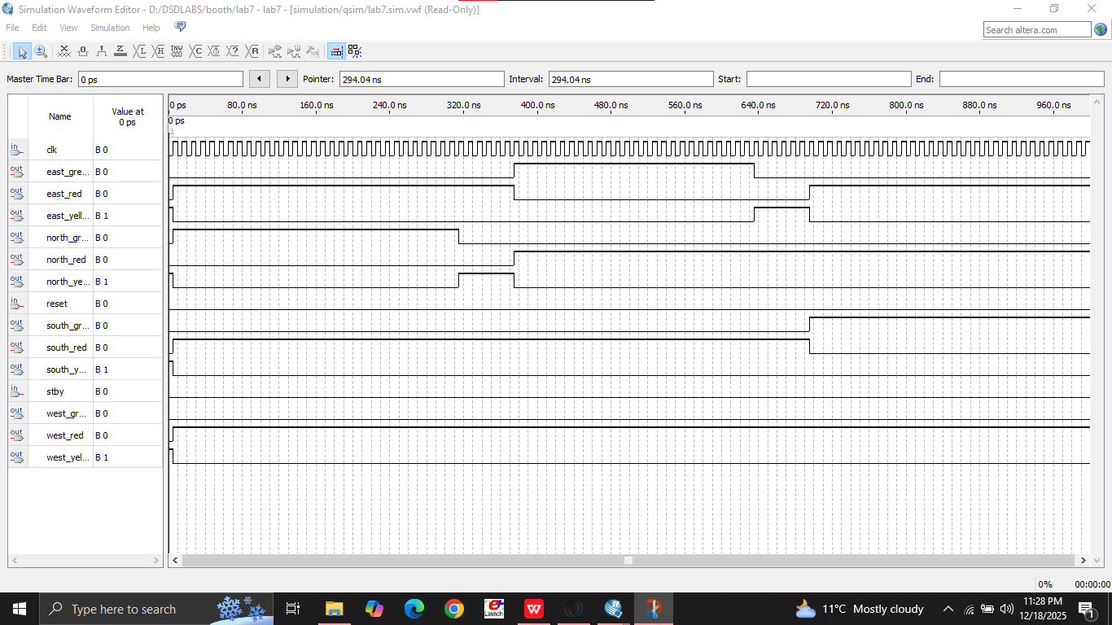

Lab 10
library ieee;
use ieee.std_logic_1164.all;
use ieee.numeric_std.all;

entity sram is
generic (
WIDTH : integer := 4;
DEPTH : integer := 4;
ADDR : integer := 2
);
port (
Clock : in std_logic;
Enable : in std_logic;
ReadEn : in std_logic;
WriteEn : in std_logic;
ReadAddr : in std_logic_vector(ADDR-1 downto 0);
WriteAddr : in std_logic_vector(ADDR-1 downto 0);
Data_in : in std_logic_vector(WIDTH-1 downto 0);
Data_out : out std_logic_vector(WIDTH-1 downto 0)
);
end sram;

architecture Behavioral of SRAM is

-- RAM array declaration
type ram_type is array (0 to DEPTH-1) of
std_logic_vector(WIDTH-1 downto 0);

signal tmp_ram : ram_type := (others => (others => '0'));

begin

--------------------------------------------------
-- READ PROCESS (Synchronous Read)
--------------------------------------------------
process (Clock)
begin
if rising_edge(Clock) then
if Enable = '1' then
if ReadEn = '1' then
Data_out <= tmp_ram(
to_integer(unsigned(ReadAddr))
);
else
Data_out <= (others => 'Z');
end if;
end if;
end if;
end process;

--------------------------------------------------
-- WRITE PROCESS (Synchronous Write)
--------------------------------------------------
process (Clock)
begin
if rising_edge(Clock) then
if Enable = '1' then
if WriteEn = '1' then
tmp_ram(
to_integer(unsigned(WriteAddr))
) <= Data_in;
end if;
end if;
end if;
end process;

end Behavioral;

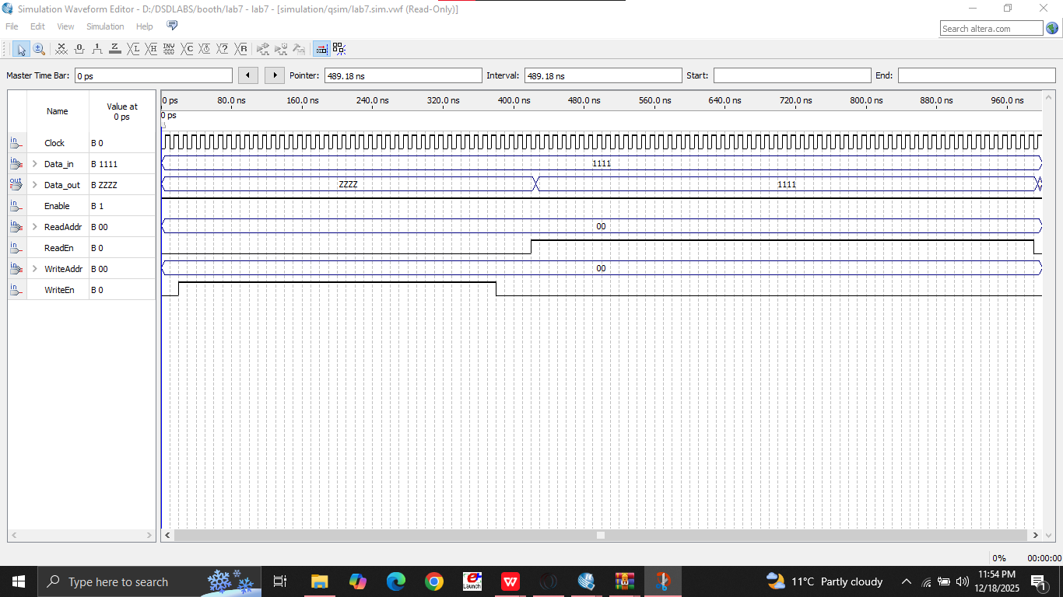

Lab 11
library IEEE;
use IEEE.STD_LOGIC_1164.ALL;
use IEEE.NUMERIC_STD.ALL;

entity Stack_FSM_Controller is
Port (
Clk : in STD_LOGIC; -- System Clock [cite: 76]
Rst : in STD_LOGIC; -- Active High Reset [cite: 76]
Push : in STD_LOGIC; -- Control input [cite: 77]
Pop : in STD_LOGIC; -- Control input [cite: 77]
Data_In : in STD_LOGIC_VECTOR(7 downto 0); -- 8-bit input [cite: 73, 79]
Data_Out : out STD_LOGIC_VECTOR(7 downto 0); -- 8-bit output [cite: 81]
Full : out STD_LOGIC; -- Status flag [cite: 82]
Empty : out STD_LOGIC -- Status flag [cite: 82]
);
end Stack_FSM_Controller;

architecture Behavioral of Stack_FSM_Controller is
-- RAM Array 16x8 as specified in block diagram [cite: 60, 74]
type RAM_ARRAY is array (0 to 15) of STD_LOGIC_VECTOR(7 downto 0);
signal stack_mem : RAM_ARRAY := (others => (others => '0'));

-- Stack Pointer (SP) [cite: 17]
signal sp : integer range 0 to 16 := 0;

-- State Definitions [cite: 65, 66, 67, 68]
type state_type is (s_Idle, s_Push, s_Pop);
signal current_state, next_state : state_type;

begin

-- FSM State Transition [cite: 64]
process(Clk, Rst)
begin
if Rst = '1' then
current_state <= s_Idle;
elsif rising_edge(Clk) then
current_state <= next_state;
end if;
end process;

-- Next State Logic with Exception Handling [cite: 33, 67, 68]
process(current_state, Push, Pop, sp)
begin
next_state <= current_state;
case current_state is
when s_Idle =>
-- Push only if not full [cite: 25, 67]
if Push = '1' and sp < 16 then
next_state <= s_Push;
-- Pop only if not empty [cite: 31, 68]
elsif Pop = '1' and sp > 0 then
next_state <= s_Pop;
else
next_state <= s_Idle;
end if;

when s_Push =>
next_state <= s_Idle;

when s_Pop =>
next_state <= s_Idle;

when others =>
next_state <= s_Idle;
end case;
end process;

-- Datapath Logic: Memory Array & SP Management [cite: 42, 51]
process(Clk)
begin
if rising_edge(Clk) then
if Rst = '1' then
sp <= 0; -- SP resets to 0
Data_Out <= (others => '0');
else
case current_state is
when s_Push =>
stack_mem(sp) <= Data_In; -- Write to SP [cite: 24]
sp <= sp + 1; -- Increment SP [cite: 24]

when s_Pop =>
Data_Out <= stack_mem(sp - 1); -- Read from top [cite: 30]
sp <= sp - 1; -- Decrement SP [cite: 30]

when others =>
null;
end case;
end if;
end if;
end process;

-- Status Flags logic [cite: 36, 39]
Full <= '1' when sp = 16 else '0';
Empty <= '1' when sp = 0 else '0';

end Behavioral;

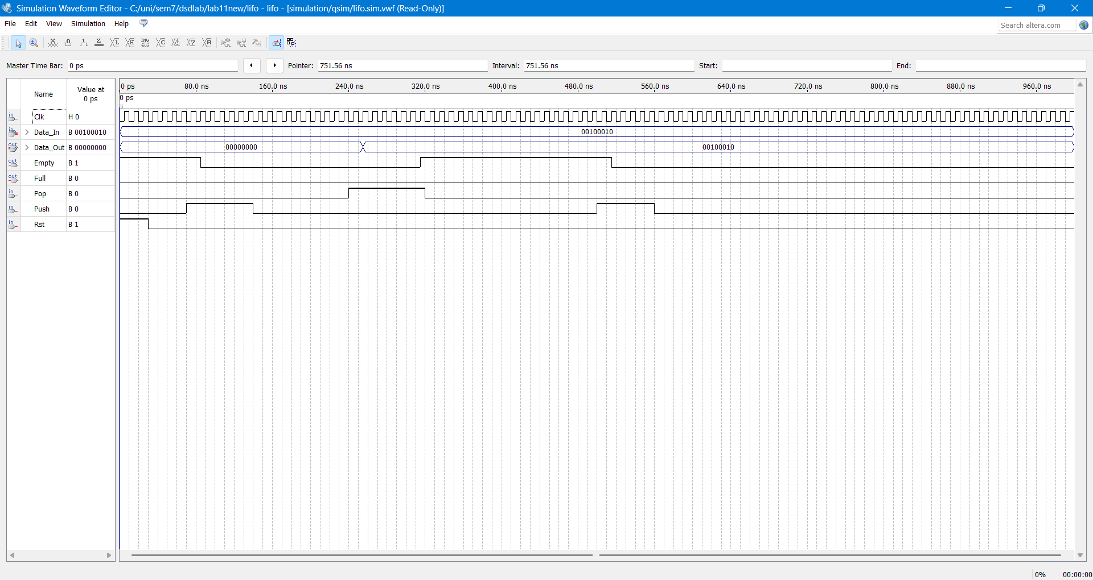

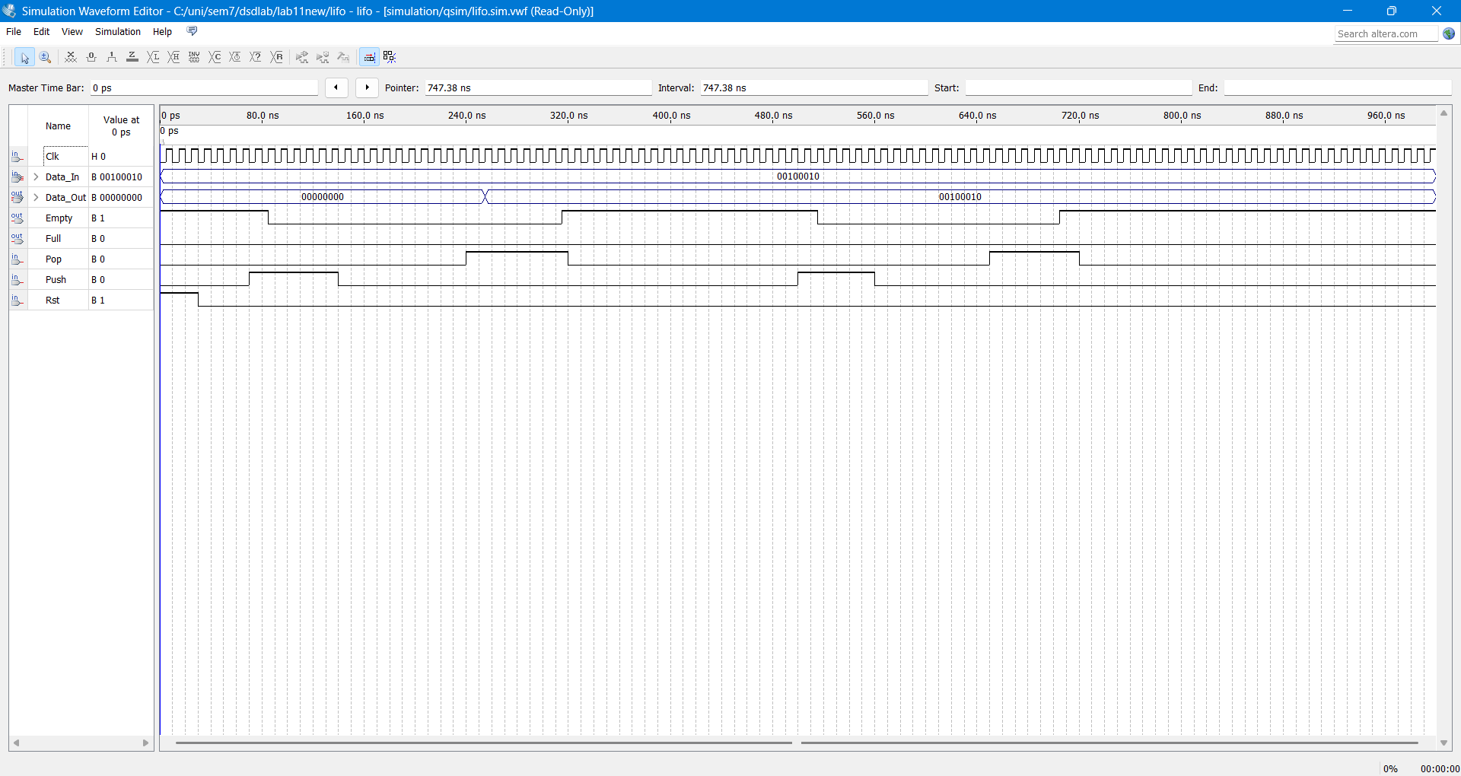

This lab focuses on designing a hardware-based Last-In-First-Out (LIFO) stack using VHDL. Unlike RAM, which uses random access, a stack restricts access to the "Top" via a Stack Pointer (SP) that manages addresses automatically. The system integrates a 16x8 RAM array with a Finite State Machine (FSM) to control PUSH and POP operations. Key objectives include handling memory exceptions like Overflow (stack full) and Underflow (stack empty) using dedicated status flags. Verification involves simulating the design to ensure data is retrieved in the correct reverse-chronological order

Lab 12
library IEEE;
use IEEE.STD_LOGIC_1164.ALL;
use IEEE.NUMERIC_STD.ALL;

entity Cache_Controller is
Port (
Clk : in STD_LOGIC;
Reset : in STD_LOGIC;
Start_Btn : in STD_LOGIC;
Switch_Addr : in STD_LOGIC_VECTOR(7 downto 0);
Led_Hit : out STD_LOGIC;
Led_Miss : out STD_LOGIC
);
end Cache_Controller;

architecture Behavioral of Cache_Controller is

-- 1. Define States [cite: 82]
type state_type is (s_IDLE, s_READ, s_COMPARE, s_RESULT);
signal current_state, next_state : state_type;

-- 2. Define Memory (Tag RAM 8x5) [cite: 43, 83]
type tag_array is array (0 to 7) of STD_LOGIC_VECTOR(4 downto 0);
constant TAG_MEMORY : tag_array := (
0 => "00001", -- Index 000: Tag 00001 (0x08) [cite: 68]
1 => "11111", -- Index 001: Tag 11111 (0xF9) [cite: 69]
7 => "10101", -- Index 111: Tag 10101 (0xAF) [cite: 70]
others => "00000" -- All other lines are empty [cite: 71]
);

-- Internal Signals
signal stored_tag : STD_LOGIC_VECTOR(4 downto 0);
signal input_tag : STD_LOGIC_VECTOR(4 downto 0);
signal index : integer range 0 to 7;
signal match : STD_LOGIC;

begin

-- Extract Index and Tag from Switch_Addr [cite: 41, 42]
-- Index: [2:0], Tag: [7:3]
index <= to_integer(unsigned(Switch_Addr(2 downto 0)));
input_tag <= Switch_Addr(7 downto 3);

-- 3. Process 1: Sequential State Transitions [cite: 84]
process(Clk, Reset)
begin
if Reset = '1' then
current_state <= s_IDLE;
elsif rising_edge(Clk) then
current_state <= next_state;
end if;
end process;

-- 4. Process 2: Combinational Logic [cite: 85]
process(current_state, Start_Btn, index, input_tag, stored_tag, match)
begin
-- Default values
next_state <= current_state;
Led_Hit <= '0';
Led_Miss <= '0';

case current_state is
when s_IDLE =>
if Start_Btn = '1' then
next_state <= s_READ;
else
next_state <= s_IDLE;
end if;

when s_READ =>
-- Retrieve Tag from array [cite: 87]
-- In simulation/FPGA, this state provides the clock cycle for memory access
next_state <= s_COMPARE;

when s_COMPARE =>
-- Perform comparison [cite: 87]
next_state <= s_RESULT;

when s_RESULT =>
-- Latch result to LEDs [cite: 88]
if (TAG_MEMORY(index) = input_tag) then
Led_Hit <= '1';
Led_Miss <= '0';
else
Led_Hit <= '0';
Led_Miss <= '1';
end if;

-- Stay here until button is released [cite: 37]
if Start_Btn = '1' then
next_state <= s_RESULT;
else
next_state <= s_IDLE;
end if;
end case;
end process;

end Behavioral;
